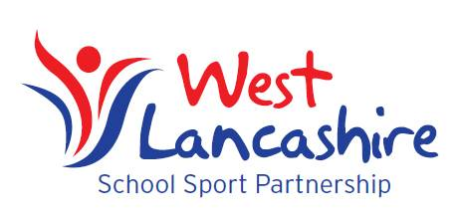

**Dear Parent,**

**The West Lancashire School Sport Partnership would like to thank you for your support at the variety of sports events and competitions throughout the year. Where possible we encourage parental presence and support and work alongside school staff to provide a safe, enjoyable experience for all our pupils.**

**Sports leadership is a huge part of our programme and young people from the local Secondary Schools will officiate at many of our events. Your son/daughter may well be involved in this progression when they move onto Secondary Education. Unfortunately we have had some situations where young leaders have been challenged by parents in respect of decisions they have made. As a result we would like to outline the following Code of Conduct.**

**Code of Conduct at Events**

* **Please follow the instructions of the organiser/school member of staff with regard to spectator areas. Designated areas are set to enable the smooth running of the event and protect the welfare of all pupils.**
* **Please respect the decisions of our young leaders. They are undergoing a development process in officiating and leadership and will make mistakes. Their confidence will be undermined if decisions are questioned.**
* **We encourage all spectators to cheer and appreciate good play from everyone not just the team you are supporting.**
* **Please refrain from coaching your child/team from the sideline as this may well undermine the instructions of their member of staff and lead to confusion.**
* **As we are sure you are aware appropriate language should be used at all times.**
* **Please follow the instructions of the organiser/school member of staff with regard to the dismissal of pupils at the end of the event in order that all pupils are handed over to parents in a controlled, safe manner.**